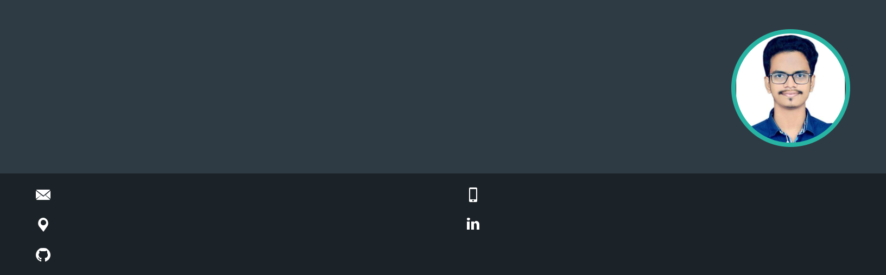Sahil Siddiqui

Software Developer

Aspiring for a challenging career in an esteemed organization scaling new heights and be successful in both my personal and professional life thereby contributing to company growth. Looking for an opportunity as Software developer/Software Development Engineer in an esteemed organization

[ssiddiqui946@gmail.com](mailto:ssiddiqui946@gmail.com)

Bengaluru, India

[github.com/SIDDIQUI-SAHIL](https://github.com/SIDDIQUI-SAHIL)

**WORK EXPERIENCE**

**Project Engineer**

Wipro Limited

*10/2019 - Present*, *Bengaluru Achievements/Tasks*

Supported a fortune 500 client on the mobility department. Key Technologies worked: Airwatch MDM, Intune. Trainings Undergone :



.Net framework, Business Etiquettes. C#, Airwatch MDM, Asp.net, Ado.net, Basic Sql.



**PERSONAL PROJECTS**

Tinder Web App Clone

A web app clone of popular online dating app Tinder. Using MERN Stack(Mongo dB, Express js, React Js, Node js )



Tik Tok Web App Clone

A web app clone of popular video sharing social networking service app- Tik Tok. Using MERN Stack(Mongo dB, Express js, React Js, Node js )



Instagram Web app Clone

A web app clone of Instagram. Using MERN Stack(Mongo dB, Express js, React Js, Node js )



Whatsapp Web app Clone

A web app clone of Whatsapp. Using MERN Stack(Mongo dB, Express js, React Js, Node js )



9561706100

[linkedin.com/in/sahil-siddiqui-8416b8195](https://www.linkedin.com/in/sahil-siddiqui-8416b8195/)

**SKILLS**



C++ Javascript MERN Stack Express js



Mongo Db React js HTML CSS Nodejs



Adobe Photoshop Microsoft Oﬃce

**ACHIEVEMENTS**

President(Chair) of IEEE Student Branch, KITS Ramtek

Winner of Anusandhan(A National Level Paper Presentation Event).

**CERTIFICATES**

Javascript- The Complete Guide 2021

*Basic to advance Javascript course*

CSS- The Complete Guide 2021

*Basic to advance CSS course*

Mern Stack Bootcamp

*basic to advance MERN stack development.*

**LANGUAGES**

English Hindi

*Full Professional Proficiency* *Native or Bilingual Proficiency*

|  |  |  |  |  |  |  |  |
| --- | --- | --- | --- | --- | --- | --- | --- |
| **EDUCATION** | |  | **INTERESTS** | |  |  |  |
|  |  |  |  |  |  |
| **Bachelor of Engineering(B.E.)** | | |  |  |  |
|  |  |  |  |  |
|  |  |  |  |  |
| Rashtrasant Tukdoji Maharaj Nagpur University | | | Web development | | Cricket | Music |  |
| *06/2015 - 06/2019*, |  | *7.26 CGPA* |  |  |  |  |  |
| *Computer Technology* | |  |  |  |  |  |  |
| Project: Web application for | | Project: Python based |  |  |  |  |  |
| online appointment with | | application for placement |  |  |  |  |  |
| docctor. | | prediction using |  |  |  |  |  |
|  |  | classification. |  |  |  |  |  |



**High School(10+2)**

Hislop College

*06/2013 - 02/2015*, *67.85%*